BAT WEBS SOLUTION

# TASK 1: Introduction to Machine Learning in Data Science

## MACHINE LEARNING()

As an individual, I went through deep research to understand what exactly machine learning is which led me to this definition-

*“Machine learning is a kind of artificial intelligence that allows machines to learn and develop without being explicitly programmed. It entails developing algorithms that learn automatically from previous data, allowing computers to make predictions or judgments. Machine learning, in essence, allows a machine to learn and improve its performance by using data, simulating the human ability to learn from experiences. Speech recognition, picture identification, fraud detection, and personalized recommendations are among examples, making it a transformative technology in various real-world applications.”*

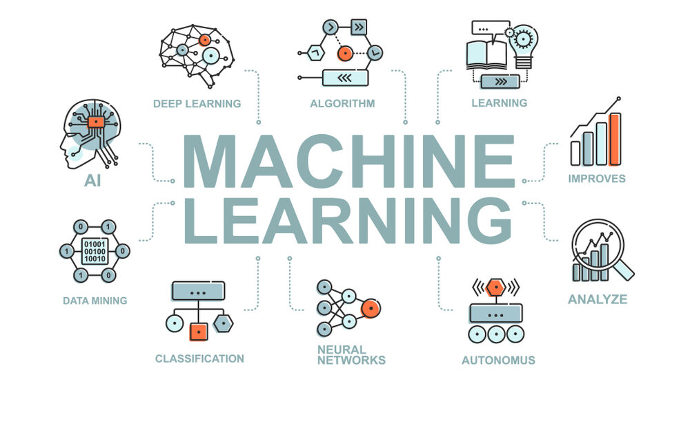

## APPLICATION OF MACHINE LEARNING()

There are plenty of use cases for ML, I was going through case studies and growth rates in the field of AI/ML, especially in ML. Machine Learning Technology has captured a huge amount of technical usage by operating on huge data. The common and widely used field for ML is Data Science.

To attain our objective, the creation of intelligent machines becomes imperative. While we can design programs to perform basic tasks, embedding intelligence into them proves challenging. Rather than relying solely on hardwiring intelligence, a more effective approach involves enabling machines to autonomously acquire knowledge. For instance, just to see the market usage of ML, these are some use cases of ML-

* Image Recognition
* Speech Recognition
* Recommender Systems
* Fraud Detection
* Self-Driving Cars
* Medical Diagnosis
* Stock Market Trading
* Virtual Try On

## Types of Machine Learning Techniques

As Machine Learning is used in a lot of domains, it is widely used in different ways by methods such as classification like-

1. Supervised learning
2. Unsupervised learning
3. Reinforcement learning

